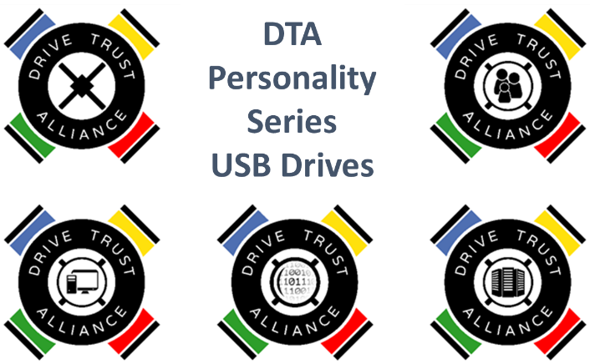

**Quick Start for Developer Personal**

**Software Installation**

1. Attach USB connector to drive and to computer. In the File Explorer, open the drive and open folder DTA. Open the subfolder Win or Mac as appropriate.
2. Run the DTA Installer program as Administrator. This installs two Self-Encrypting (SED) Drive programs:
   1. **SEDAccess** which will run in the background for just unlocking a DTA USB Drive[1] with a typed password.
   2. A **SED Control Program**. It will be one of these: **SEDControl, SEDPersonal, SEDInfoTech, SEDFamily, SEDArchive, or SEDForensic**.[2]

**Initial Setup**

1. In Programs or Apps, Go to the group DriveTrustAlliance, and run the installed SED Control program.
2. Select the DTA USB Drive in the SED Control program. A new or newly erased one will say Opal, **Setup No**, and Locked **No**. If you do not see the word **Opal**, the drive you selected is not a DTA Opal-Standard drive. If you see **Setup Yes**, you have a DTA drive that is not a new or newly erased, and has already been configured. Select another Drive that is **Opal** with both **Setup** and **Locked No**.
3. Click **Setup**. You will be asked for a password. This main screen password is the Administrator Password. Do not lose the Administrator password.
4. After a few seconds **Setup** is **Yes** and **Password** and **Lock** are active. **Password** changes the Administrator password. **Lock** locks the drive immediately and when it is powered off. **Lock** changes to **UnLock** if the drive is locked.

**Testing the Drive**

1. Unplug the USB connector for the drive and plug it back in.
2. The SEDAccess window will appear. Type in the Administrator password.
3. The drive will now show up as a volume on your computer. All data on the drive is hardware encrypted AES 256. Protection is as strong as the password.

**Setting a User Password (on any non-Personal DTA Personality Drive)**

1. Run SED Control program. Select the DTA drive.
2. Under the tab **File**, click **Administer**. You will be asked for the Administrator Password
3. Select one of the 8 Users to set a password. Type in a Password for that User.
4. Click **Apply**.

**Permanently Erasing Drive and Re-Using it**

1. Run SED Control program. Select the DTA drive.
2. Click **Erase**. Agree to the Warning. Provide the current password. The drive data is erased with no possibility of recovery.
3. A window appears that offers to format the disk. As shipped, the disk is formatted ExFAT compatible with both Windows and MAC, but pick any format or **Cancel** to format later.
4. Setup the disk with a new Administrator password and Locking as above. Disk is ready for fresh use. For security, there should always be an Administrator password on an Opal SED Drive.

**Custom Developers**

Unlike proprietary storage encryption, DTA offers developers at different levels of expertise to customize the management of DTA USB drives.

* **Highest Expertise:** Our GitHub site provides the core source code employed by our GUI personality series drives. You can alter and compile your custom solutions for Linux, MAC, and Windows.
* **Modest Expertise:** We supply a pre-compiled executable Command Line Interpreter (sedutil-cli). You must understand the TCG Opal Standards to understand how to use this low level command interface to the security subsystem in TCG Opal and Enterprise drives. Your API manuals are the TCG Opal (and possibly Enterprise) drive specifications at www.trustedcomputinggroup.org.
* **IT Management:** If you join as a Silver DTA member, at [www.drivetrust.com](http://www.drivetrust.com), we also provide sedutil-cli support and a set of shell scripts suitable for administration of drives by IT. These shell scripts can be modified and integrated into IT management as desired.

1. SEDAccess is exactly the same for any drive in the Personality Series. It only takes a typed password and submits it to the DTA USB SED to unlock it. No usernames such as “Administrator” or “User 1” are needed to unlock drives.
2. The SED Control programs only differ by what Users can do. In SEDInfoTech and Family Users authorize read and write the drives. In SEDArchive and SEDForensic Users only authorize reading, but not writing, the drive. The Administrator password always authorizes both read and write. Any SED Control program can be used interchangeably on any DTA drive in the Personality Series.